In the expanded market research, the absence commercial markets are identified including major recreational facilities., working offices and study area. Based on the research results, a negative pressure ventilation system is the most efficient and economical solution for the prevention of transmitting the air-borne virus in small and dense spaces, also public place.

With the most concerned, Eldercare and hospital would the projects in urgent need of renovation with a , meanwhile those facilities need to be functioning continuously. Most of the facilities actually complied with standard ASHRAE 170-2013/2017

In conclusion, if we are determined that a unit on the wall for the doctors office

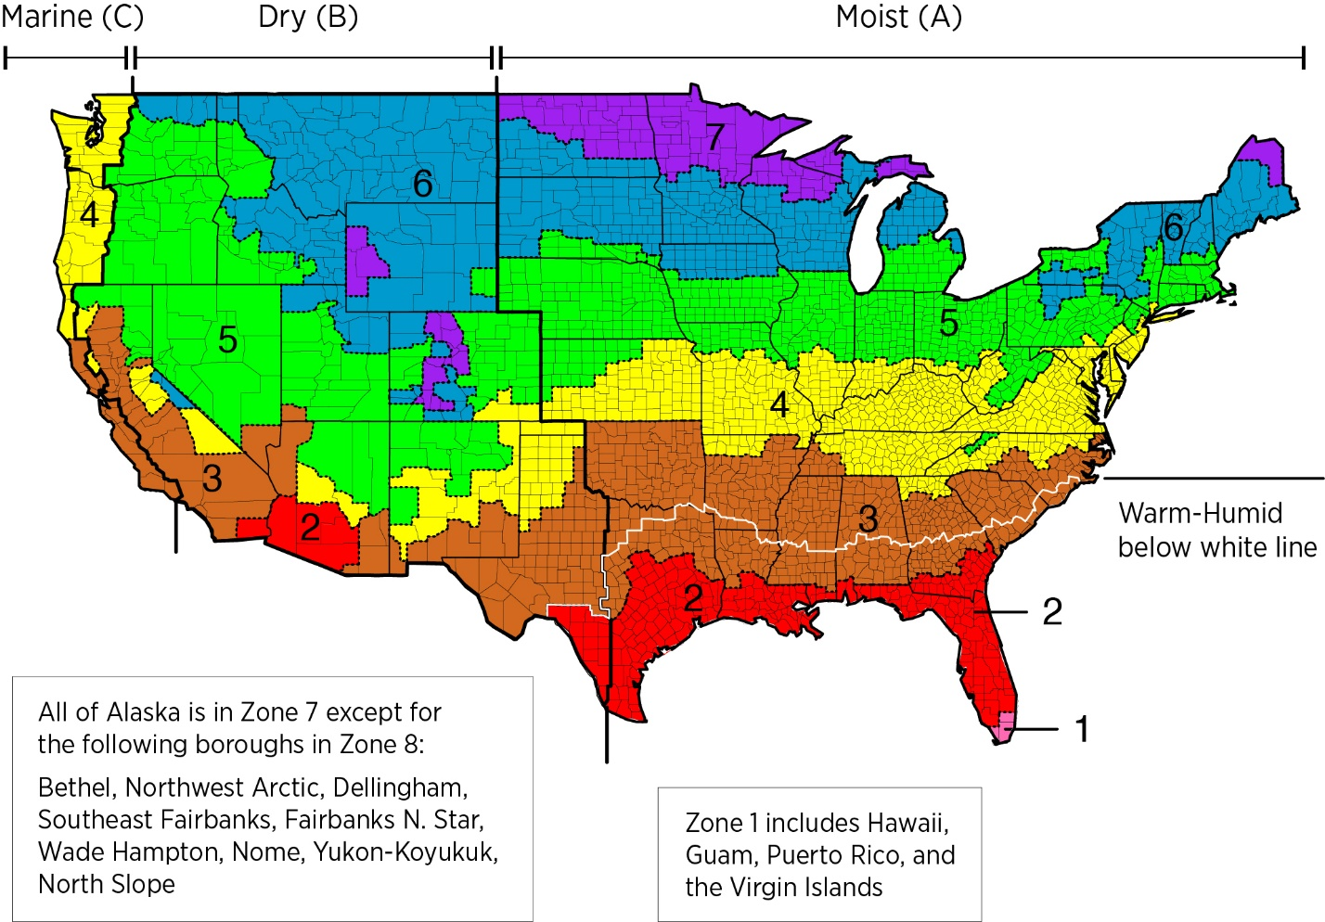

Combined our products with the US climate zone, it would not be reasonable to apply negative pressure ventilation to all of the public infrustature